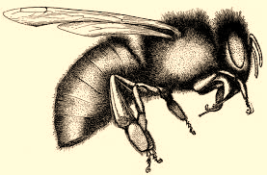
LEARNING SERIES: Honey Bee Plants

Introduction

This event will teach beekeepers about different honey bee plants to use in both home landscapes and around properties. We will be installing a pollinator garden at Kimmel Orchard and discussing the structure, layout, and species in the plantings and their role in the larger ecosystem of home landscapes.

After this lecture, you will have a better understanding of:

- Different plants that provide resources for bees

- Best practices on plug installation and home garden maintenance

- Requirements for first year management of pollinator plantings

- What “flows” are and how their timing is important

- How to organize a pollinator planting to be an attractive naturalistic landscape addition

- What the different flower structures are, and what kinds of bees are attracted to them

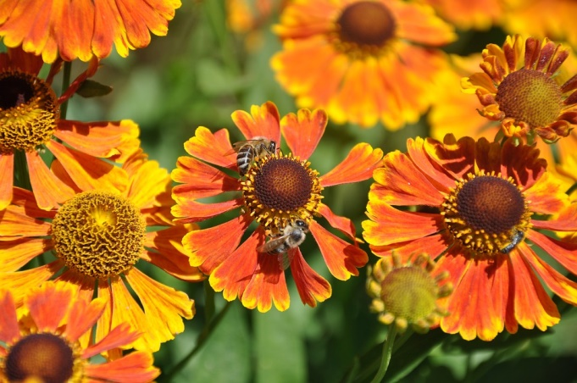
- What other types of plants are good in pollinator plantings and why

Great Plains Master Beekeeping Learning Objective: 1.5

Location: Kimmel Orchard

Time: April 20th 9:30-11:30

Cost:
$10 for Great Plains Master Beekeeping members
$25 for nonmembers

Pre-register at: https://gpmb.unl.edu/learning-series-honey-bee-plants and pay at the door

